|  |  |
| --- | --- |
| Date | 19 September 2022 |
| Team ID | PNT2022TMID54420 |
| Project Name | PERSONAL ASSISTANCE FOR SENIOR WHO ARE SELF-RELIANT |

**SPRINT-4**

**MIT APP INVENTOR**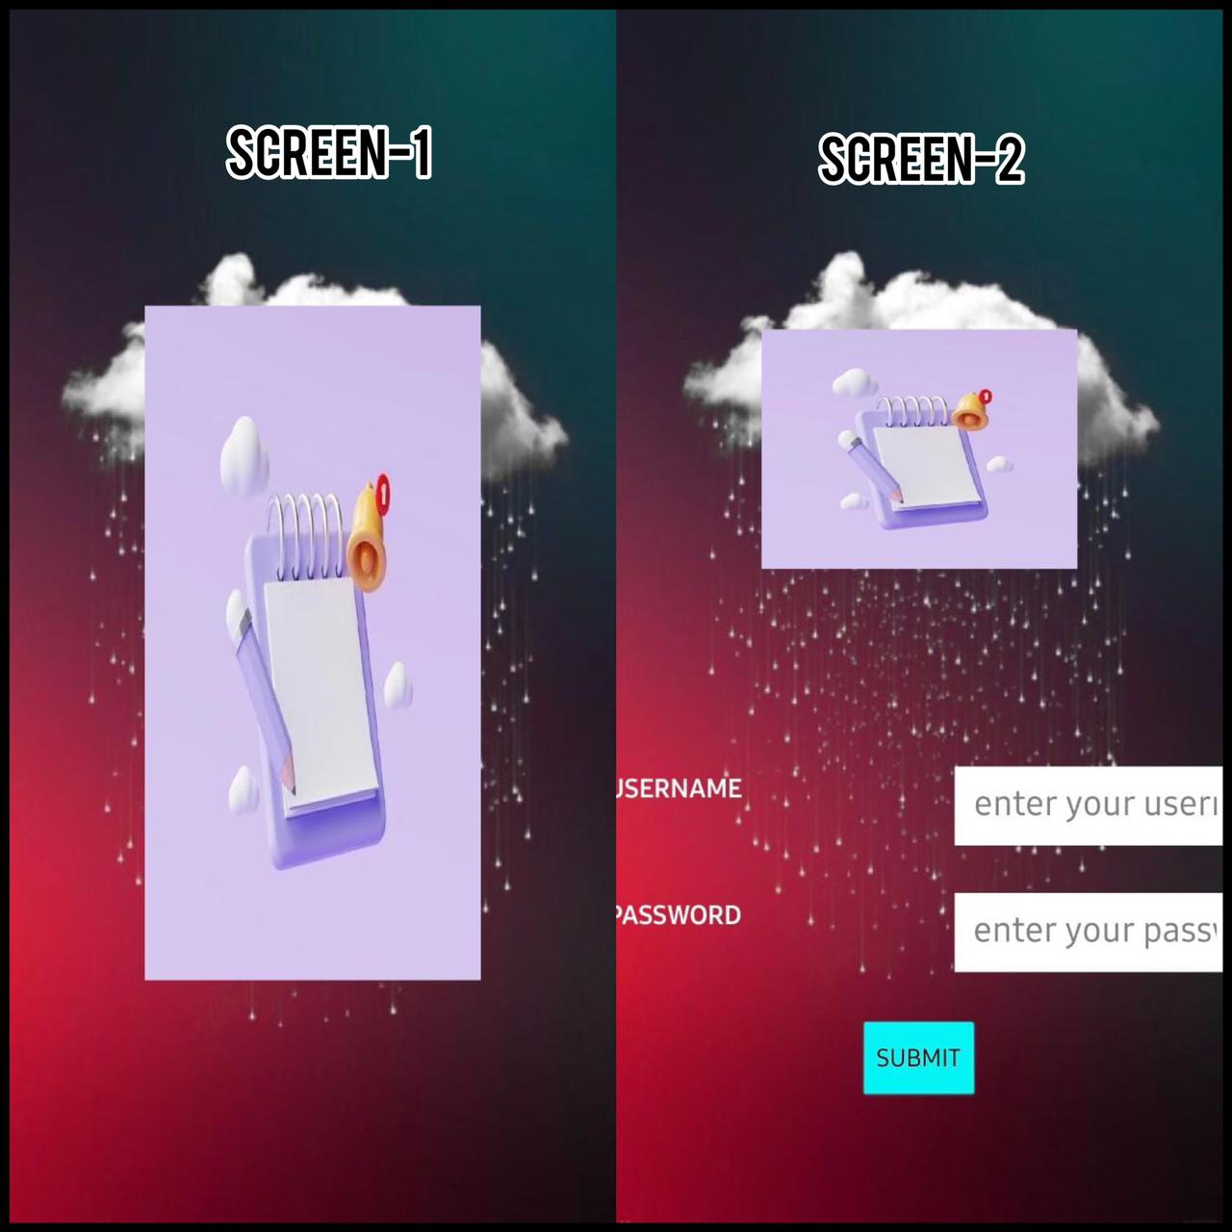

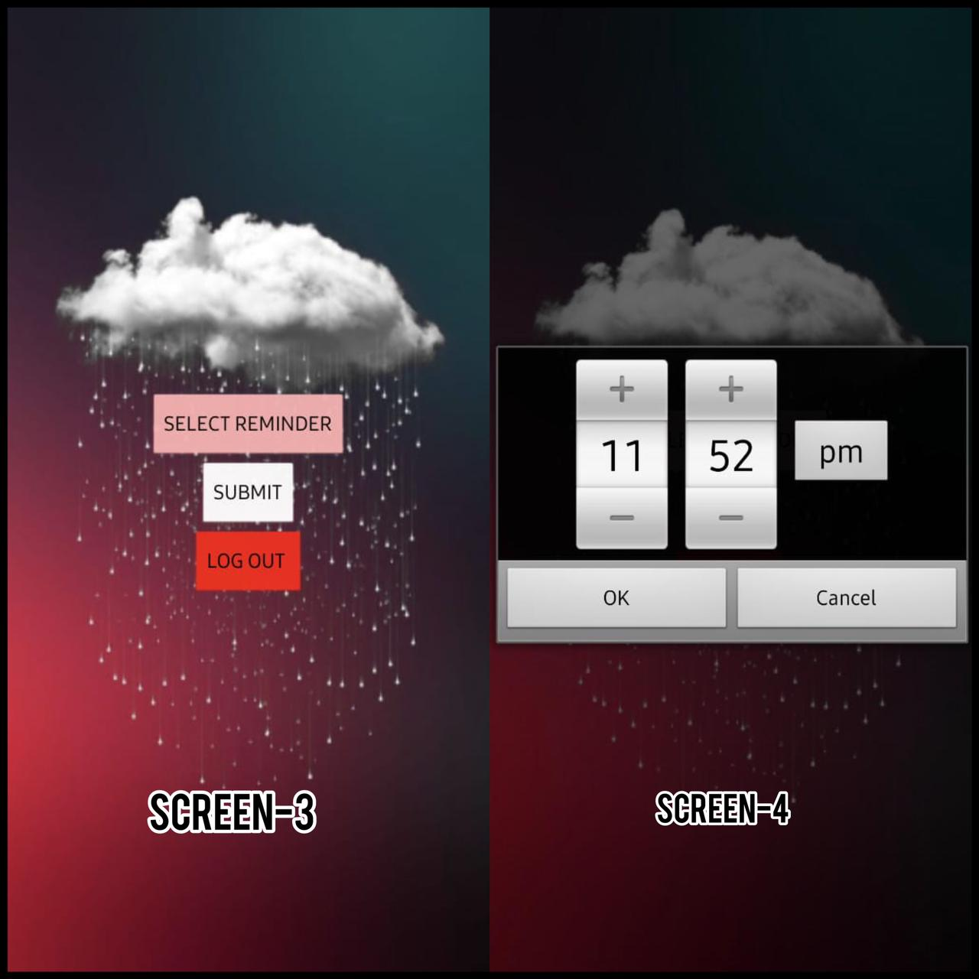

**NODE-RED DASHBOARD**

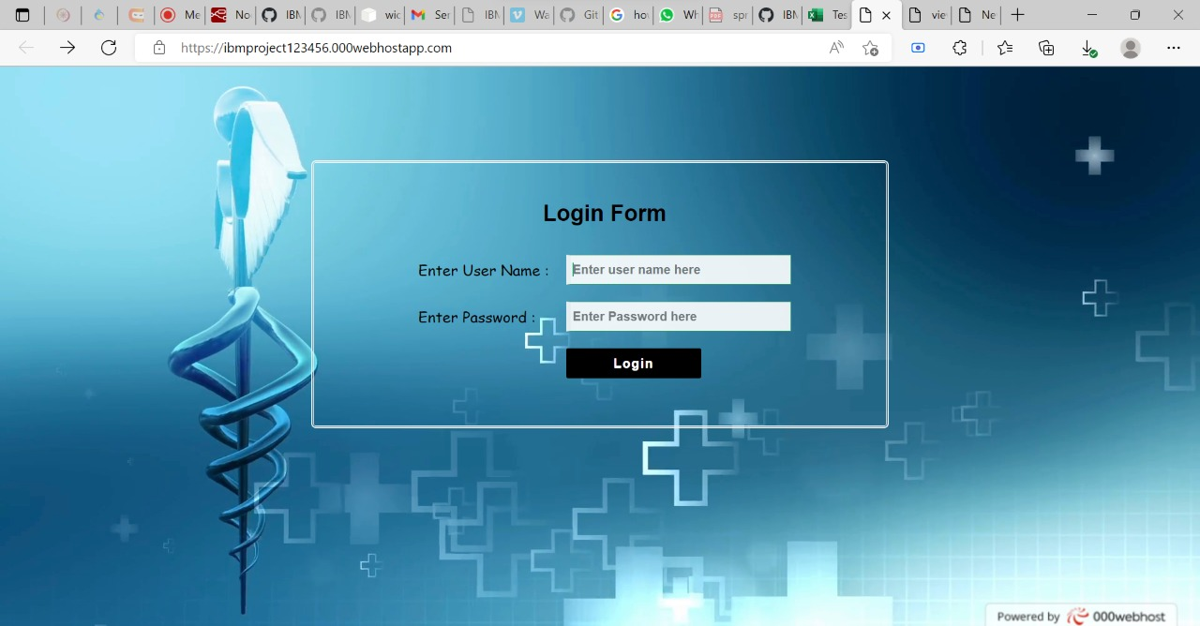

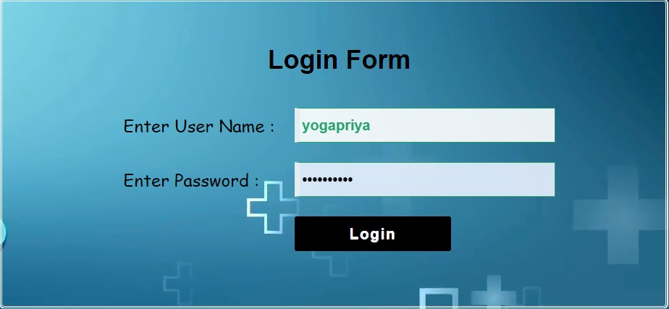

**POP-UP MESSAGE APPEARS:**

